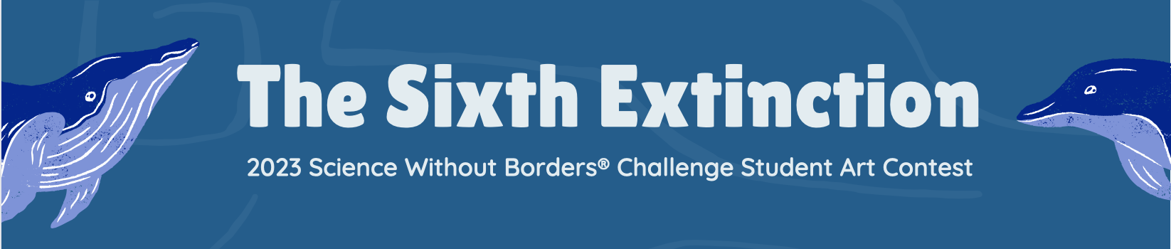
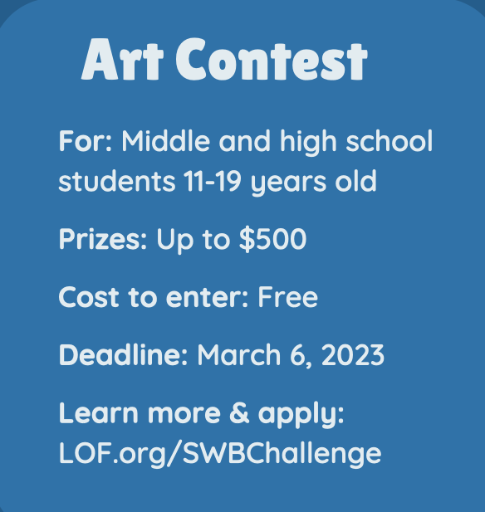
About the Contest
The Science Without Borders® Challenge is an international art contest run by the Khaled bin Sultan Living Oceans Foundation that inspires students from all over the world to be creative while learning about important ocean science and conservation issues.

For this year’s contest, you can help create awareness about endangered marine species by creating a piece of artwork that highlights the beauty and importance of a marine species that is on the brink of extinction.

How to Apply
Step 1: Research this year’s theme, “The Sixth Extinction.” Information on this topic can be found at LOF.org/SWBChallenge, where you can also review the full contest rules and tips for success.

Step 2: Pick an endangered species to portray in your artwork and learn about its environment and why it is endangered. You can pick a plant or animal that spends all or part of its life in salt water, provided it is listed as endangered or critically endangered on the IUCN Red List website: iucnredlist.org/search.

Step 3: Create a drawing, painting, or other 2-dimentional piece of artwork that highlights the beauty and importance of an endangered marine species. Spend time on your artwork and be creative! The artwork will be judged your creativity, artistry, and craftsmanship as well as its visual impact and your understanding of the theme. The size of the artwork does not matter, but keep in mind that if you are selected as a semi-finalist, you will be asked to mail your artwork to us for the final rounds of judging. No digital artwork is allowed.

Step 4: Write a short description of your artwork and how it relates to the theme, “The Sixth Extinction.”

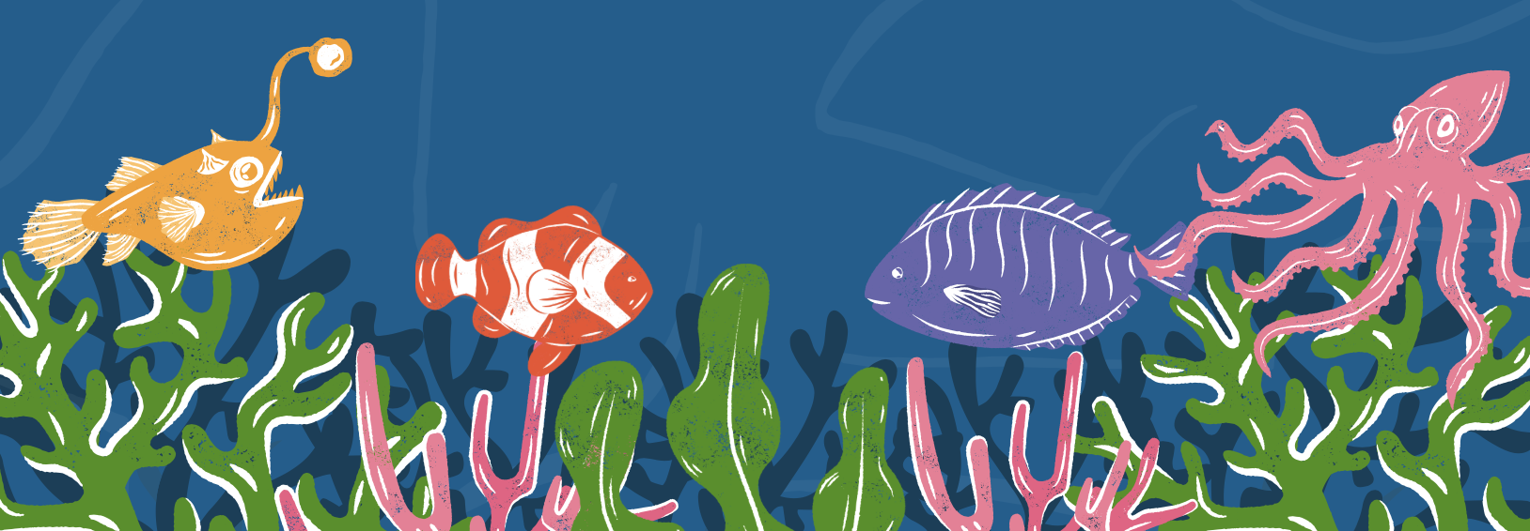
Step 5: Complete the online entry form at LOF.org/SWBChallenge and upload a picture of your artwork. You will be asked to provide contact information for a teacher and a parent or guardian (if you are under the age of 13, they will be asked to provide consent). This process takes time, so make sure not to wait until the last minute! All entries must be received by March 6, 2023, to be eligible to win.

